WEEKLY REPORT #18
Group# and Name: May1615 Portable ECG Atrial Fibrillation Detection
Client/Advisor: Mani Mina, Rakshak Sarda, Benjamin Sjulson

Attendees/Role:
Ian Abbott (Web Designer)
Nic Dubois (Lead Hardware Integration)
Aaron Melcer (Hardware Collaborator)
Donathan Morgan (Leader, Communicator, Connector, Hardware Collaborator)
Keegan Mumma (Software Collaborator)
Seth Rickard (Lead Software Integration)

Past week accomplishments (2/21/16 - 2/27/16) o We made attempts to reduce ECG circuit components and was successful in mitigating noise allowing us to get a better signal.
- We tested the ECG circuit by using electrodes and attaching them to Aaron, Nic, and Donathan. Although we got some readings from Aaron, we were able to collect the best impulse results from Nic. The results appear in the comment section. o Seth, Ian, and Keegan are starting up the Bluetooth and Android applications so that we can begin our attempt to integrate the hardware with the software.

Plan for coming week (2/28/16 - 3/5/16) o The Software group will continue collaborating to understand the microcontroller and begin Bluetooth preparations.
- The EE’s will work on making the feedback from ECG circuit electrodes clearer and more versatile for different body sizes. o We plan to keep up the weekly meetings on Tuesdays and Thursdays at 2pm and also on Saturdays.
- The CE’s group plans to finish more programing on the microcontroller in the coming weeks.

Pending issues
- Having a clear heart pulse signal retrieval in circuit ECG design electrodes from all body sizes.
- Software group still needs to finish preparations for the microcontroller.
- We need all parts ready for the integrated ECG detection device.

Individual contributions
- Nic Dubois, Aaron Melcer, and Donathan Morgan are working towards a better design for the ECG circuit.
- Seth Rickard and Keegan Mumma are now researching and working to program the microcontroller and prepare Bluetooth integration.
- Ian Abbott is still trying to get data to send over Bluetooth. Data is being sent but not consistently or in a readable format

Individual hourly contribution
NAME | Hours This Week | HOURS  Cumulative
Ian Abbott | 4 | 54
Nic Dubois | 3 | 47
Aaron Melcer | 3 | 47
Donathan Morgan | 3 | 46
Keegan Mumma | 3 | 46
Seth Rickard | 12 | 66

Comments and extended discussion
Current ECG Circuit:
We took Prof. Tuttle’s and Ben’s advice, reducing the number of circuit components and flattening them. Now the circuit looks much better and we have dramatically reduced the random noise in circuit. We now are using battery inputs for our source voltage. We are also using BIOPAC electrodes for connectivity to pick up the heart impulse signals. We use the electrodes in the following ways and get decent results for our heart rhythm signals that appear on the oscilloscope.
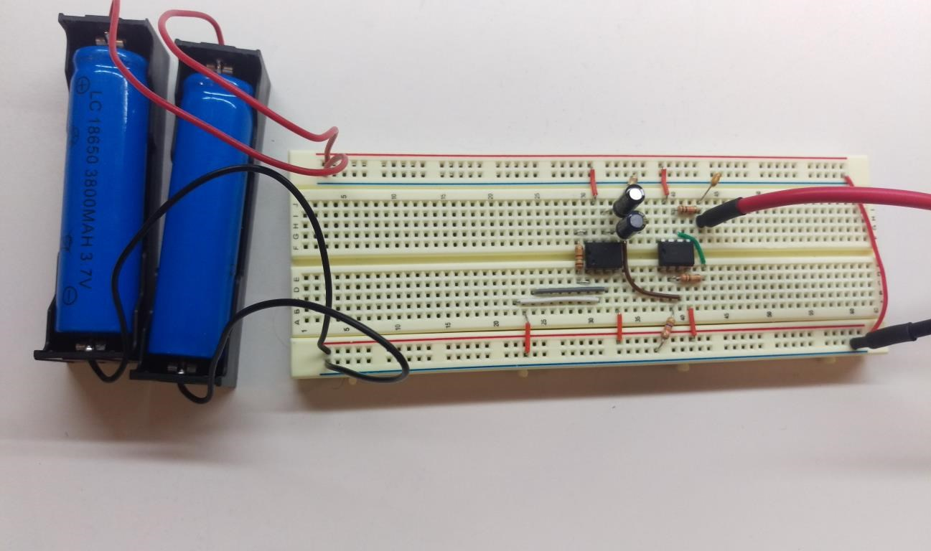

BIOPAC Electrodes
Location of the BIOPAC Electrodes including an undemonstrated ground on the inner ankle.
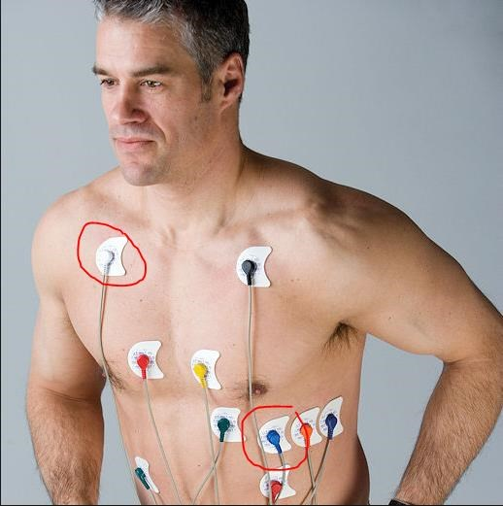
http://www.nikomedusa.com/images/kidney_electrodes.jpg
Oscilloscope pictures:
The Black and white oscilloscope pictures appear clearer and similar to proper ECG readings.
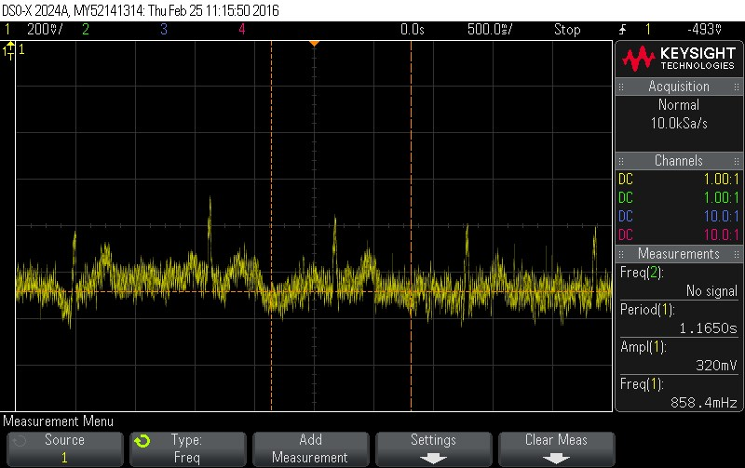

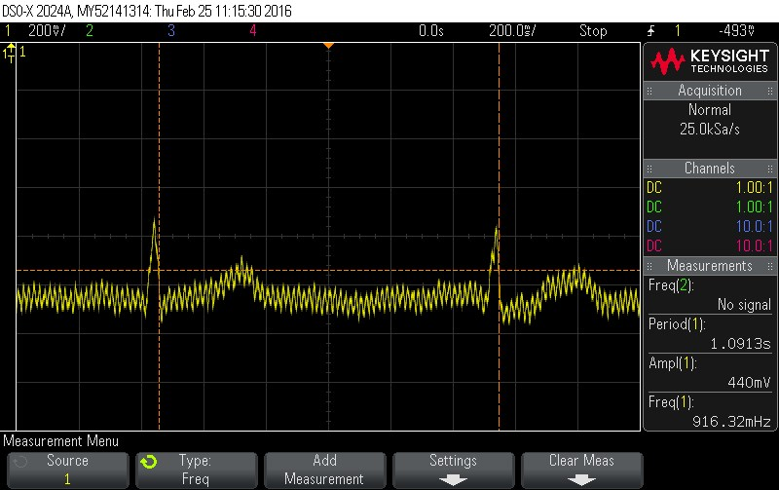

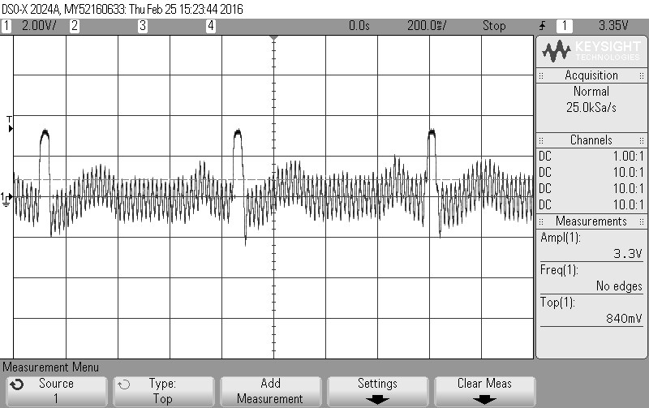

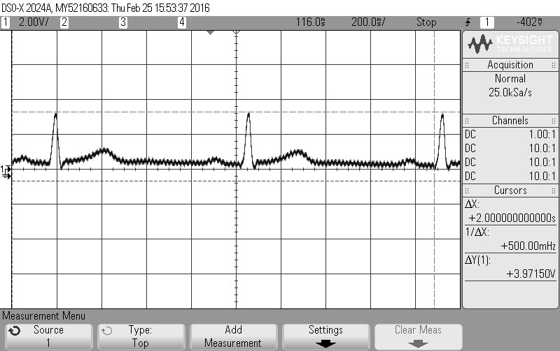

Standard Electrocardiogram:
Our above results are very similar to the proper electrocardiogram results that appear in the following image.
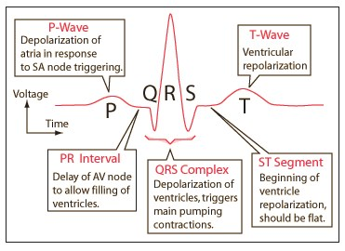
http://hyperphysics.phy-astr.gsu.edu/hbase/biology/ecg.html

