Atrial Fibrillation Detection Device Design Document

Advisor: Mani Mina
Client: Dr. Rakshak Sarda
Contact: Benjamin Sjulson

Group:

Ian Abbott
Nicholas Dubois
Aaron Melcer
Donathan Morgan
Keegan Mumma
Seth Rickard

Table of Contents

Table of Contents
Project Statement
System Requirements
Power Supply
Amplifier Circuit
Bluetooth Controller
Android application
System Analysis
Cost
Environment
User Interaction
UI Design
Block Diagrams
System Overview
Software Module Interaction
Amplifier Circuit Diagram
Specifications
Implementation Challenges
Testing
Appendix A:
User Interface Flow Diagram
Appendix B:
Home Screen
Setup
Bluetooth
Information
Heartrate

Project Statement

With ever increasing demand for healthcare solutions and an ever increasing population, low cost easy access testing equipment will become essential. Atrial fibrillation is an oft undiagnosed heart condition that affects many around the world. It is especially hard to detect in rural areas where expensive testing equipment is not always accessible. However, one piece of technology reaches almost every corner of the world, the smartphone. Our aim is to create a low cost heart monitor to pair with an Android phone to detect atrial fibrillation. These monitors could then be distributed with the free companion application to collect heart data and report on the subject’s heart condition.

System Requirements

The solution will consist of four components; power supply, amplifier circuit, bluetooth controller, Android application. The power supply will provide power to the amplification circuit and the bluetooth controller. The amplifier circuit’s puropose is to amplify and clean the subjectr’s heart rate for the bluetooth controller. The bluetooth controller will read the value from the amplifier circuit and send the digital value to the Android phone for processing by the Android application.

Power Supply
Functional
- Includes recharge circuit/rechargeable supply
- Provides 3.7V at 3800mAh
- Corresponds appropriately with the micro-controller unit (MCU) and instrumentation amplifiers

Non-functional
- Fits within “pocket-sized” enclosure
- Light weight

Amplifier Circuit
Functional
- Modifies low voltage heart signal to be read by MCU at higher potential
- Low power for less draw on battery circuit
- Low-pass filter for signal buffering
- Safety circuit to prevent damage to device or user injury
- Life span to accommodate lengthy use

Non-functional
- Occupies minimal area
- Utilizes low cost components

Bluetooth Controller
Functional
- Connect the bluetooth radio to the Android device
- Digitize the analog signal from the amplifier circuit
- Buffer the data when the Android device is disconnected
- Intelligent data summation of periods in between heartbeats

Non-functional
- Low power consumption
- Robust design to withstand the wear and the elements
- Embedded program error resistant

Android application
Functional
- Connect to the bluetooth monitor and control the connection
- Record the values from the monitor and store them in a database
- Display the current monitor output as a graph
- Display old values from the monitor stored in the database
- compress data at regular intervals to reduce storage size

Non-functional
- UI / UX follows android best practices, material design
- User interface is “intuitive” as it is possible that this will not be used by en_us
- abstracted strings for easy translation
- Quick response when pulling up large sets of data

System Analysis

The system’s main objective is to be a low cost and reliable heart monitor for deployment in low income areas of the world. Therefore, components will be chosen for their durability and price. The final product should be able to be shipped across the globe, withstanding the harsh conditions of transport and use in these environments. As this is an embedded system with an unknown repair schedule it is assumed that the device must operate as long as physically possible. To ensure this, the software on the device must be extremely robust and fault tolerant. The factors will be taken into consideration in every facet of our design.

Cost
One of the major considerations for this project is the cost of the final product. If this solution is to be sold or given away in low income areas. The components must be inexpensive to manufacture. The amplification circuit is comprised of commercially manufactured components. The bluetooth connection subsystem is made of mass produced Texas Instruments chips. These components are mass produced and relatively inexpensive, the largest cost is the Lithium-Ion battery used to power the circuit. The Android application, once programmed, will be distributed for free of charge on the Google Play store. These measures were done in order to make the product available to the largest number of people.

Environment
After cost, the next consideration is the dependability of the system. The software for the bluetooth controller will follow the JPL Rules for Developing Safety Critical Code to increase the likelihood that the embedded code will have the longest uptime possible. This robustness will be mirrored by the hardware design.

User Interaction
The design of the solution, both hardware and software, should be as easy to understand and use. Because, the heart monitor may be used by people whose first language might not be english. This will be accomplished on the software side by use of icons and simple material design. The strings used in the application will be abstracted into language files to aid in internationalization. The hardware side will be as simple as possible to attach the leads and connect to the Android device. Icons will also help instruct how to operate the hardware and leads.

UI Design
In order for the application to be most effective, it needs to be both simple and intuitive. In order to achieve this, we are going for a minimal approach in keeping a low number of direction options on each screen to create an easy navigation system. There is also a menu in the top right corner of each screen that will allow the user to jump to any screen from any point within the application. For a visual representation of the application navigation, see the flow diagram, go to Appendix A. To see each screen individually, along with a description, go to Appendixes B.
Block Diagrams

System Overview

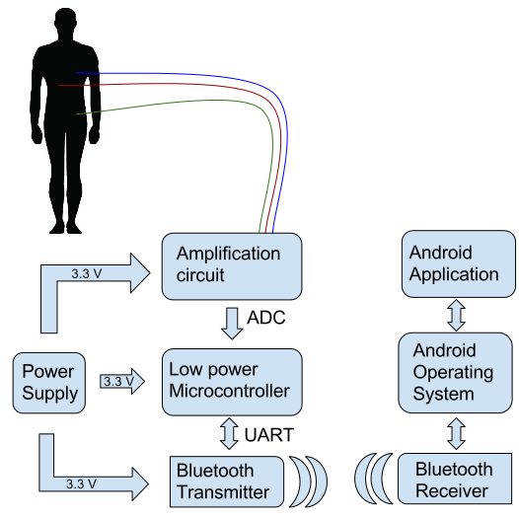

Software Module Interaction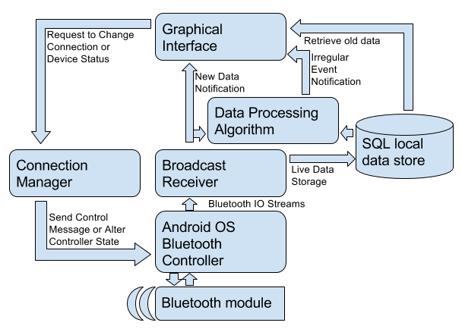

Amplifier Circuit Diagram
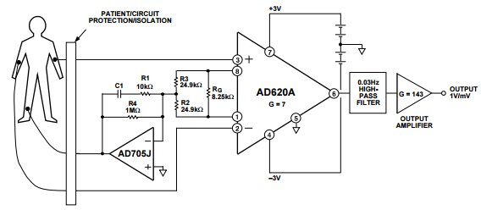
Specifications

I/O
- Each one of the hardware components will be supplied with 3.3 Volts. This will provide the circuit with adequate power to change from analog to digital, power the microcontroller, and to power the Bluetooth transmitter. The output on the Android device will show the current heart rate and it will also show the subject’s previous heart rate
Interface
- The interface will be as simple as possible to make it easy for anyone with any background to operate the device. The strings will be abstracted into different language files so that people who speak different languages will be able to understand what is displayed on the screen. There will be minimal wordage to make it easy for all to understand.
Hardware/software
- The Bluetooth transmitter needs to be able to transmit a heart rate at a fairly fast speed. It also needs to buffer the data so that even when the application is closed it can store and alert the subject to a problem. Also, the circuit needs to be cheap and reliable so that it can be produced cost effectively.

Implementation Challenges

The largest challenge will be the interconnection between the individual subsections.
- Creating a reliable connection between the amplification circuit and the subject
- Wiring the amplification circuit and the bluetooth controller
- Establishing a bluetooth connection between the hardware and the Android application
- Transmitting the heart waveform efficiently to the application
Testing

The individual subunits may be unit tested. The java code of the Android application will be tested using the jUnit testing framework included with Android Studio. These tests will include activity flow logic, data reception, and data processing. Physical circuit testing will be done before and after integration with the MCU. Signals will be provided at the input and assessed at the output for accuracy and desirability.

The bluetooth connection manager will be tested functionally with the android application. The user interface and user experience concerns will be tested by interacting with the application. When signal identification is successful, the circuit will be tested using human heart beats to determine appropriate functionality according to our specifications.

Appendix A:

User Interface Flow Diagram

Home
Info

Setup

Connection
Heartrate

Appendix B:

Home Screen
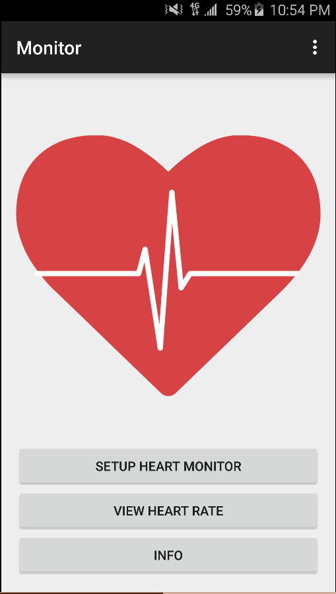 | The majority of the Home screen is made up of the main logo, with three buttons below it. The SETUP HEART MONITOR button will take the user to the Setup screen, the VIEW HEART RATE button will take the user to the Heart-rate screen, and the INFO button will bring up the information box.

Setup
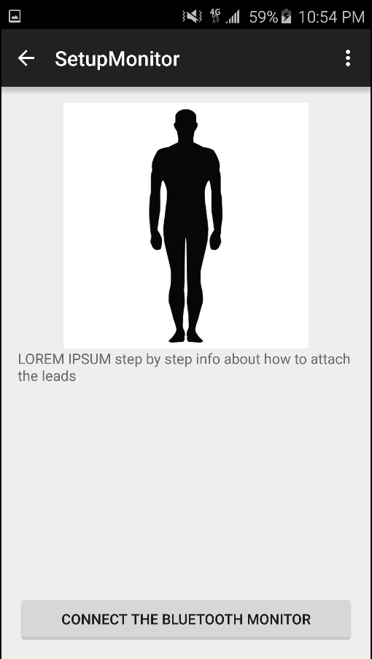 | The Setup screen consists of a diagram of how to attach the leads to the user’s body for maximum accuracy. The CONNECT THE BLUETOOTH MONITOR button takes the user to the connection box.

Bluetooth
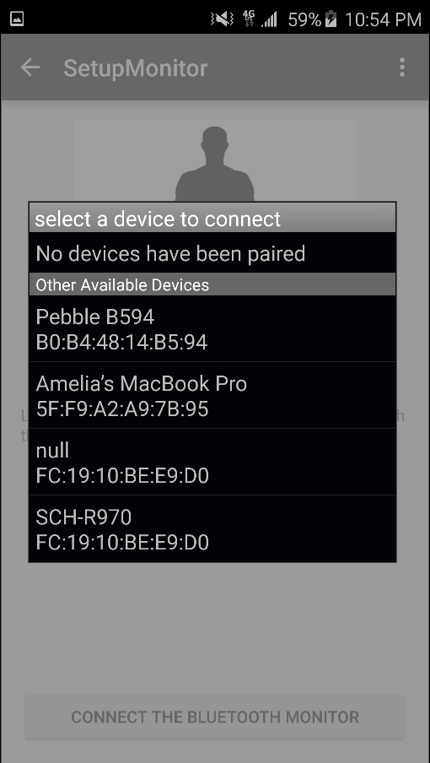 | The connection box lists all available Bluetooth devices that the application is capable of connecting to.

Information
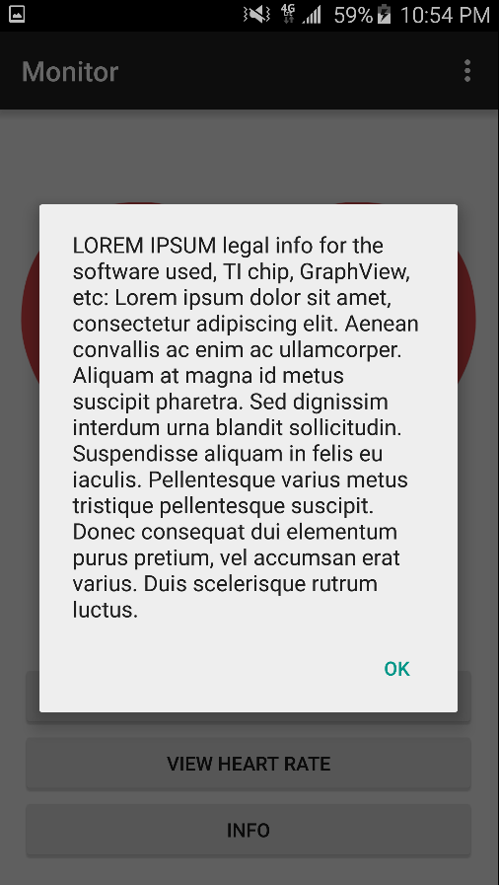 | The Information screen contains legal information regarding Bluetooth usage, libraries included, and hardware specifications.

Heartrate
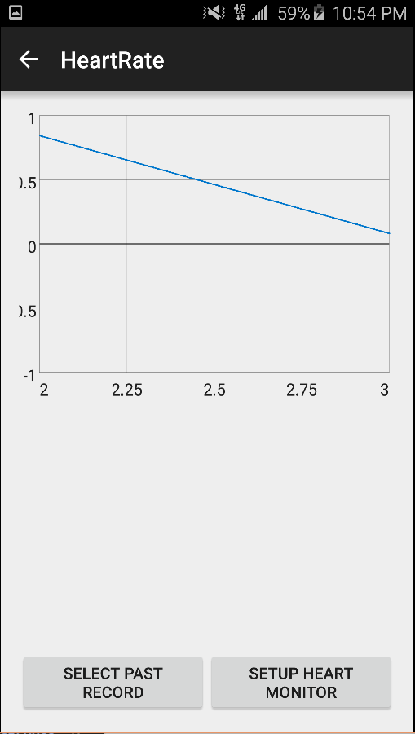 | The majority of the Heart-rate screen is dedicated to the graph containing information about the user’s heartbeat. The SELECT PAST RECORD will allow the user to past heartbeat activity, and the SETUP HEART MONITOR button will once again take the user to the Setup screen.

